MASP

Impact of MASP

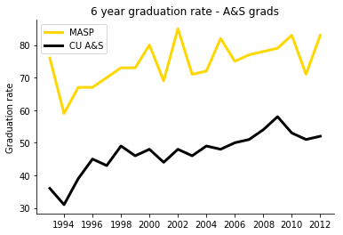  
This section would include details and analysis of the data we’re given to conclude that participation in MASP is related to better graduation rates. Since we don’t have the data, we should keep this relatively vague for the general design.

Community

This section should be about one of MASP’s core components: the community. Here we can include information and quotes from graduates that were in MASP in regards to how MASP helped them succeed. Include pictures of the community

Assets and Opportunities MASP gives

This section should include information about what MASP provides to students to help them succeed. This includes classes and presentations on how to study and do well in the University.

This will include access and connections to other organizations, like CAPS.

This section will be more data-based, more in-depth than the first page.

We should gather as many different types of data to make sure that MASP’s effectiveness is being highlighted. 2 or 3 graphs are a requirement here, if not more.

Distribution of MASP majors

Here we can add a description of what the majority of majors are. By my guess, it’s going to be MCDB. Regardless, this section should explain how the people in the majority can help one-another using the MASP office area to discuss homeworks and such, in order to succeed. This would also be a good spot to put info about the majority major grad rates v. the campus’ grad rates for that major.

As mentioned in our discussion, we should probably mention retention rates for the University. That data can be added below.

